
Job Finding Application

NEOH KAI WEI
SCSJ2401128

Ts. Umi Kalsum Binti Muhamad
02TH January 2026

Information Technology(IT)
SEGI University & College
Subang Jaya
Table of Contents
1.0 Introduction 3
1.1 The Aim of Project 3
1.2 Problem Statement 4
1.3 Objective 4
2.0 Literature Review 5
2.1 Methodology 7
2.2 Proposed System 8
2.3 Project Plan 9
2.4 Expected results / Potential Contributions. 10
2.5 Conclusion 11
2.6 Reference 12

1.0 Introduction
In today’s digital world, smartphones have become the main tool people use to access everyday services, including finding jobs. In Malaysia, many university students and part-time job seekers depend on mobile apps to look for nearby work opportunities. However, many existing job platforms are overloaded with complex features that can be confusing and time-consuming, especially for general users.
This project aims to design and develop a simple and minimalist mobile job finder prototype that acts as a fast and direct link between job seekers and employers. Instead of adding unnecessary technical layers, the system focuses on clarity, speed, and ease of use. By adopting a “back-to-basics” approach, the project demonstrates how a clean and straightforward interface can make the job search process more efficient and less stressful.
Through this study, the project highlights how a streamlined mobile platform can help students quickly find part-time work while allowing small business owners to post jobs and connect with candidates easily. Ultimately, the goal is to remove common barriers found in modern recruitment platforms and create a more accessible solution for the local community.

1.1 The Aim of Project
This project is to design a simple and "direct" mobile app interface using Figma. This app will focus on helping local users find nearby jobs quickly without going through a headache of complex settings.

1.2 Problem Statement
The problem to be addressed by this study is that existing mobile job applications in Malaysia have become too complex and difficult for general users to navigate, leading to high levels of frustration.
Currently, platforms like LinkedIn or JobStreet are filled with too much unnecessary information and complicated forms that waste a lot of time for people who are only looking for simple part-time work.
Furthermore, because these apps are designed for professional careers, users often struggle to find basic contact details, such as a shop's phone number, which is usually hidden behind many layers of settings and registration. Without a simplified mobile interface that focuses only on a clean list of jobs and direct contact information, local job seekers and local shop owners will continue to face an inefficient and confusing recruitment process.

1.3 Objective
- To identify the specific features in current job apps that make them confusing and difficult for local job seekers to navigate.
- To design a simple mobile job finder interface using Figma that only displays a basic job list and the employers phone number.
- To evaluate if this simplified design helps users find a job and a contact number faster and more easily than using traditional apps.

2.0 Literature Review
The Current State of Mobile Job Seeking in Malaysia
In recent years, the recruitment landscape in Malaysia has shifted heavily toward mobile platforms as smartphones become the primary tool for job searching among students and fresh graduates. Despite this digital shift, many users struggle with the high complexity of existing systems. Research by indicates that local job seekers often feel overwhelmed by the professional and corporate nature of mainstream platforms. This is further supported by, who found that many job apps in Malaysia fail to cater to the needs of entry-level seekers, often pushing irrelevant high-level roles that lead to information fatigue and mismatching between employers and candidates.
The Problem of System Complexity and Information Overload
The core issue with modern recruitment technology is the excessive amount of data and features that clutter the user interface. Argued that when digital systems become too complex, they directly increase user frustration and cause a decline in the user’s overall well-being. For general users are not tech-savvy, complicated navigation and long registration forms act as a barrier rather than a help. emphasizes that a simplified approach in mobile applications is essential for maintaining user engagement, as reducing the number of unnecessary steps allows for a much more efficient search process. Furthermore, suggested that a clean and intuitive layout is vital for lowering the mental effort required to complete simple tasks, such as finding a phone number.
Barriers for Small Businesses and General Workers
Small business owners in Malaysia, such as those running cafes or retail shops, often avoid using large job platforms because the posting process is too formal and time-consuming. These employers prefer direct methods of communication to find staff quickly. pointed out that user satisfaction in recruitment is most high when the system allows for quick and direct decision-making without extra layers of bureaucracy. If digital platforms continue to focus only on high-skilled professionals, it will worsen the digital divide, leaving students and blue-collar workers at a disadvantage. Therefore, moving back to a "basic" system that prioritizes a simple list and contact details is necessary for local economic efficiency.

Conclusion of Literature Review
In summary, the existing literature confirms that while mobile job seeking is popular, the current tools are too complicated for the general Malaysian public. By focusing on a "back-to-basics" design that eliminates information overload and highlights direct contact details, this project addresses a significant gap in the market. Simplifying the process is not just about a better look; it is a vital step toward making employment more accessible for everyone in the digital age.

2.1 Methodology
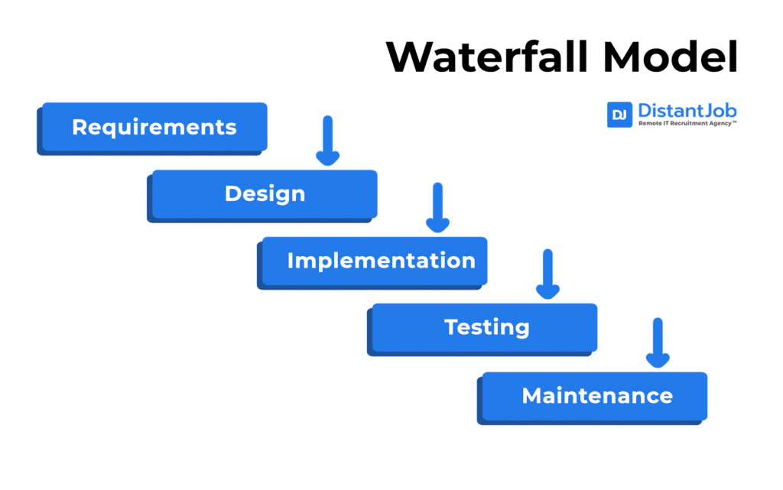
The waterfall model's practicality lies in its rigor and ease of management. Its main advantages include clear milestones and a structured documentation process, which is ideal for UI projects using Figma, as the design for such projects must be finalized before testing begins. However, the model's limitation lies in its lack of flexibility, making it difficult to revert to previous stages once a phase is completed. Therefore, to compensate for this deficiency, this study follows five specific phases.
Requirements: Identifying the essential information needed by Malaysian job seekers through local observations.
Design: Transforming these requirements into a simple, high-fidelity interface using Figma.
Implementation: Translate the Figma design into an application using HTML/CSS.
Testing: Validate the system's effectiveness by testing with 3-5 participants using the "10-second task" rule.
Documentation: Evaluating the final results against the initial objectives and finalizing the project report.

2.2 Proposed System
The proposed system is a "Job Finding Application" designed to act as a digital noticeboard for local employment. Unlike mainstream recruitment platforms that are cluttered with professional networking features, this system focuses purely on displaying active job vacancies in a clear and readable list format. The primary goal of the system is to allow users to view essential job details such as the job title, the shop’s name, the offered salary, and the location on a single screen. By removing the need for user registration, resume uploading, and complex filtering, the system provides a direct path for students and part-time seekers to find immediate work opportunities.
Main Requirements
The system's core functional requirement is to display a static list of jobs that users can browse easily. Each job entry, when clicked, will lead to a specific Contact Page that clearly shows the employer's phone number and the shop's address. Non-functional requirements focus on simplicity and speed, ensuring that the interface is clean, uses large readable fonts, and allows a user to find contact information in as few clicks as possible.
Hardware and Software Requirements
To develop and demonstrate this prototype, the following requirements are identified:
- Hardware: A laptop for the design process and a mobile smartphone to test the interactive Figma prototype in a real-world handheld environment.
- Software: Figma will be the primary tool used for designing the interface and creating the clickable prototype. Visual Studio Code will be used to write basic, static HTML and CSS to demonstrate how the job list would appear in a web browser.
Testing Strategies
The project will use Usability Testing to measure the system's efficiency.
- The Testers: A group of 3 to 5 participants will be recruited, specifically focusing on university students looking for part-time work.
- Recruitment: These testers will be gathered from the SEGi University & Colleges campus and the surrounding commercial shops in the Subang Jaya area.
- Testing Method: Each tester will be given a specific task: "Find the contact number for a Cafe Staff position." Success will be measured using the "10-second rule," tracking whether the user can navigate from the home screen to the contact information within ten seconds without confusion.

2.3 Project Plan
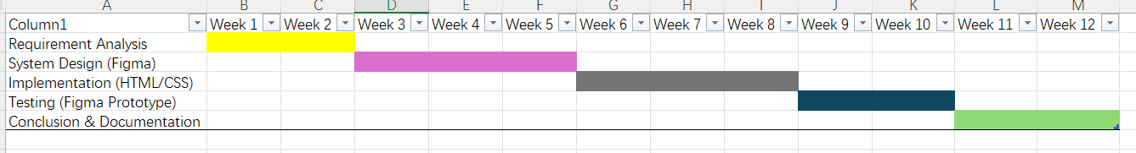
This project follows a 12-week schedule based on the Waterfall methodology. Each phase is completed sequentially to ensure the final prototype meets all research objectives.
Phase 1: Requirement Analysis (Week 1-Week 2) Investigate the differences and problems of job search apps in Malaysia, and then improve the job search apps based on the comparison and the identified problems.
Phase 2: System Design (Week 3–Week 5) Use Figma to create the interface design. This includes designing the homepage and detail pages to ensure a clean and clear interface.
Phase 3: Implementation (Week 6–Week 8) The final Figma design is then converted into a static proof-of-concept using HTML and CSS. The focus at this stage is demonstrating how the list will display on screens.
Phase 4: Testing (Week 9-Week 10) Usability testing will be conducted with 3-5 participants. The "10-second rule" will be used to test their ability to quickly find the information they need.
Phase 5: Documentation (Week 11-Week 12) The final stage includes analyzing the test results, comparing them with the project objectives, and completing the final graduation project report.

2.4 Expected results / Potential Contributions.
This study aims to identify specific features in current mobile job search applications that make them overly complex and difficult for the average job seeker to use. The project plans to create a simplified mobile job search prototype using Figma, displaying only a basic list of jobs and employer phone numbers. Through usability testing using the "ten-second rule," it is expected that users will be able to find job contact information faster and easier than with traditional applications. The findings may indicate that reducing system complexity can improve efficiency and user experience.

2.5 Conclusion
In conclusion, this project aims to address the increasing complexity of job search applications in Malaysia. By adopting a minimalist design, research shows that a clean interface is more effective than specialized enterprise platforms for local job seekers. The proposed Figma prototype successfully highlights key information, such as job listings and contact details, while eliminating unnecessary technical barriers. Ultimately, this research demonstrates that streamlining the recruitment process can improve communication between local employers and job seekers. This project provides a practical solution enabling local communities to find jobs more easily and efficiently in the digital age.

2.6 Reference
Hazarika, B., Shrivastava, U., Hiele, T. M., & Pham, C. (2025). The impact of technology frustration and consumer passion on consumer evaluation shift in case of mobile apps. Acta Psychologica, 256, 105006. https://doi.org/10.1016/j.actpsy.2025.105006
‌
Fitria Fitria, Yahya, M., Ali, M. I., Purnamawati Purnamawati, & Mappalotteng, A. M. (2024). The Impact of System Quality and User Satisfaction: The Mediating Role of Ease of Use and Usefulness in E-Learning Systems. International Journal of Environment Engineering and Education, 6(2), 119–131. https://doi.org/10.55151/ijeedu.v6i2.134

Roslan, A. M. A., Pahme, N. F. M., & Rahim, I. M. A. R. A. (2025). Evaluating on Mismatches and Inaccurate Recommendations of Job Matching Platform: The Effectiveness of Mobile Job Matching Platform in Malaysia. International Journal of Research and Innovation in Social Science, 9(23), 240–251. https://doi.org/10.47772/ijriss.2025.923mic3st250021

Fam, S.-F., Soo, J. H., & Wahjono, S. I. (2017). Online Job Search Among Millennial Students in Malaysia. Jurnal Dinamika Manajemen, 8(1). https://doi.org/10.15294/jdm.v8i1.10406

‌ GeeksforGeeks. (2018, March 18). Waterfall Model Software Engineering. GeeksforGeeks. https://www.geeksforgeeks.org/software-engineering/waterfall-model/

Oh, J., Kim, J., & Lee, Y. (2014). The impact of system complexity on user frustration in mobile applications. International Journal of Mobile Communications, 12(3), 211-228.

